Plane

Original photo
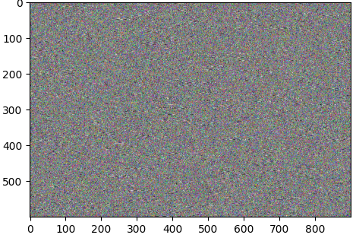
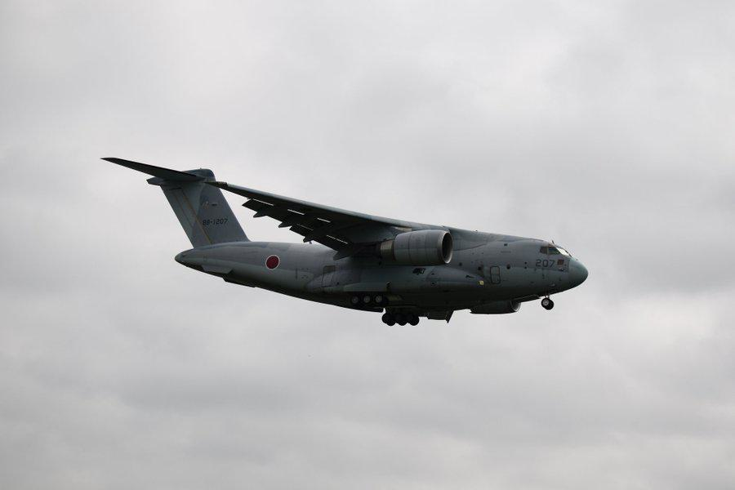

Histogram
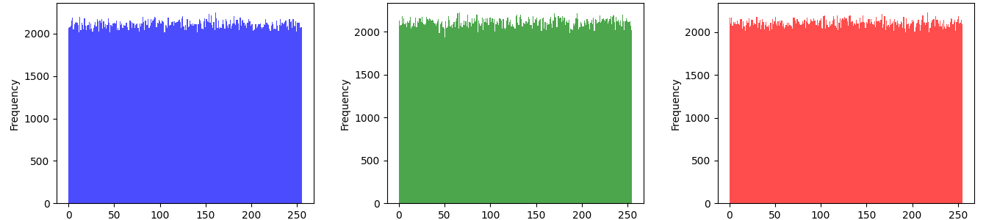
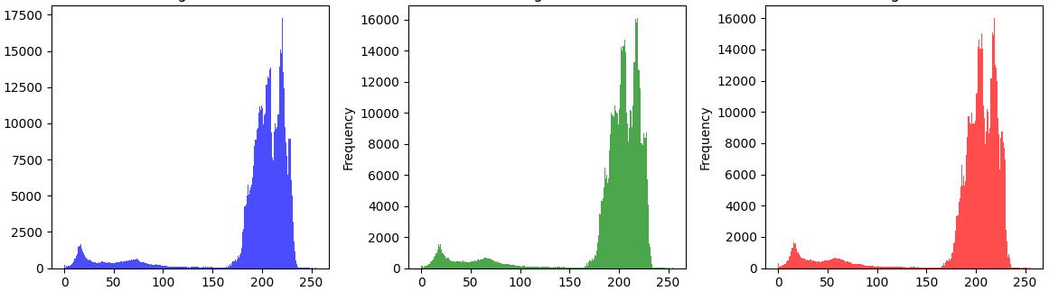

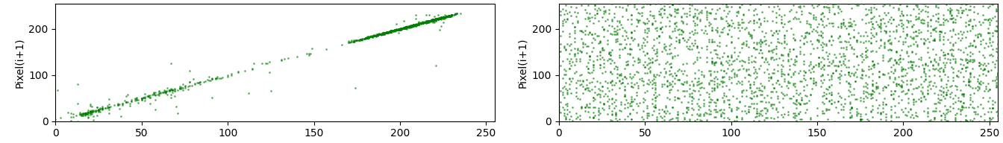
Correlation horizontal
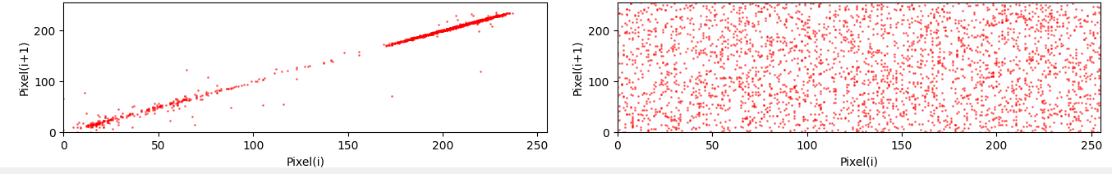
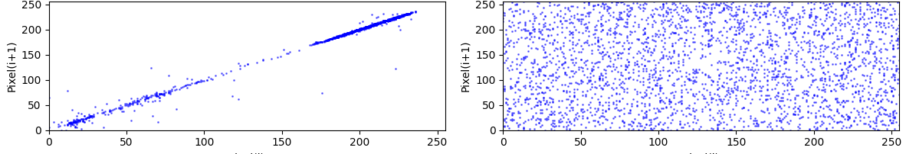

Correlation vertical

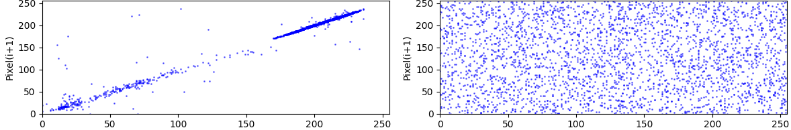
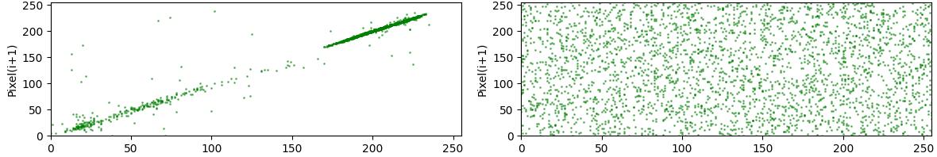
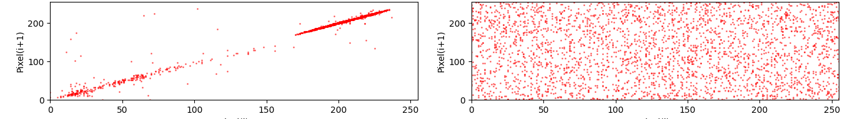

Correlation diagonal

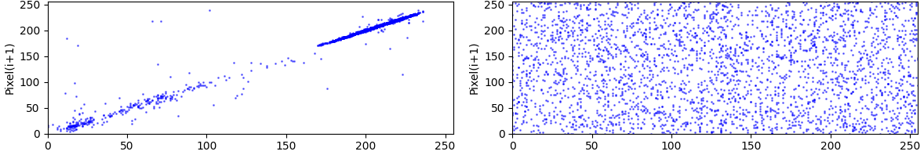
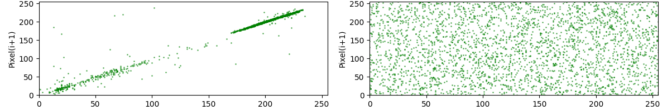
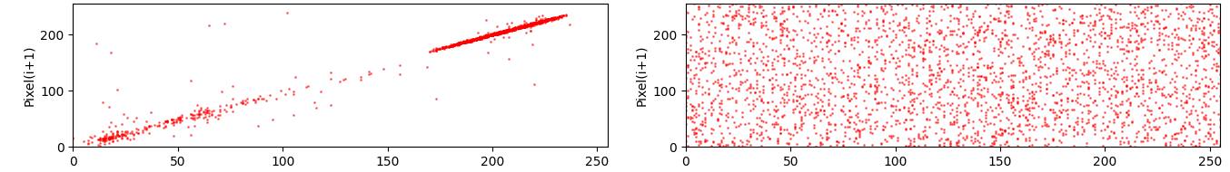

Metric | Original | Encrypted
Entropy | 6.2924 | 7.9999
PSNR | 7.2998 | -
NPCR% | 99.6107 | -
UACI% | 35.2913 | -
Correlation Horizontal (B) | 0.9899 | 0.0278
Correlation Horizontal (G) | 0.9950 | 0.0297
Correlation Horizontal (R) | 0.9955 | -0.0081
Correlation Vertical (B) | 0.9863 | -0.0429
Correlation Vertical (G) | 0.9868 | -0.0186
Correlation Vertical (R) | 0.9916 | -0.0350
Correlation Diagonal (B) | 0.9857 | -0.0256
Correlation Diagonal (G) | 0.9889 | -0.0095
Correlation Diagonal (R) | 0.9927 | -0.0082

Map

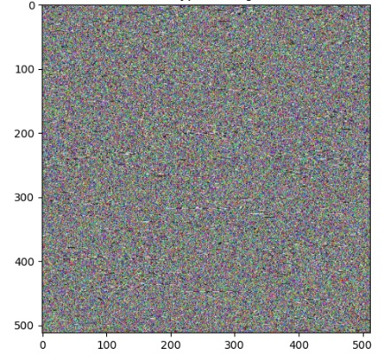
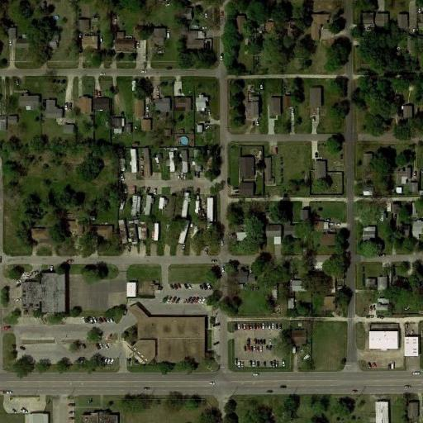

Histogram
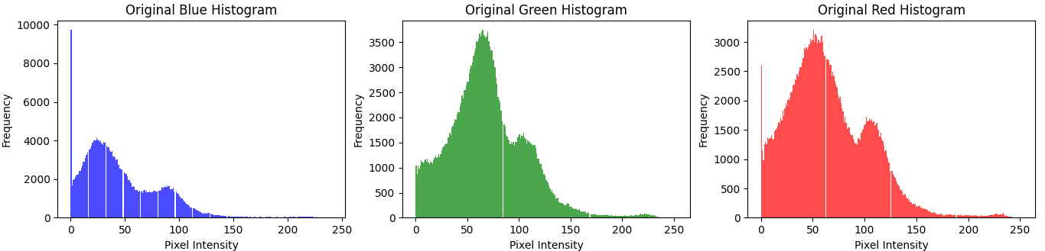

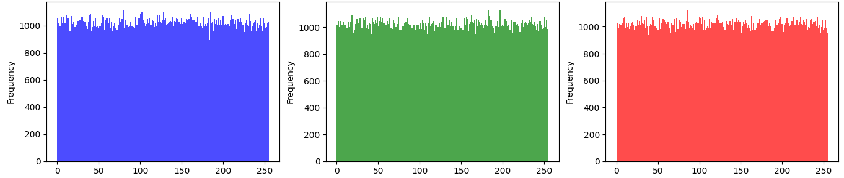

Correlation horizontal

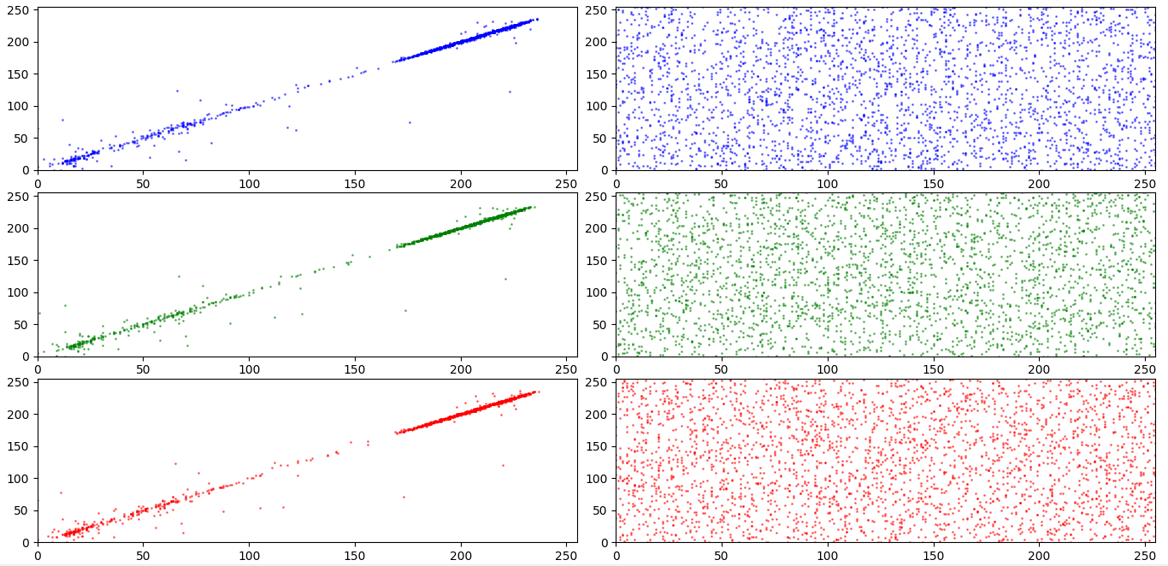

Correlation vertical

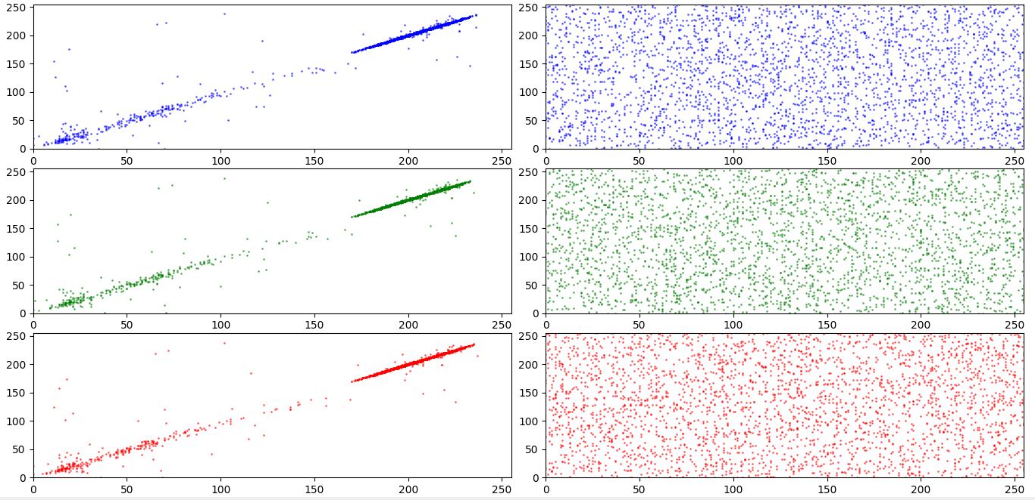

Correlation diagonal
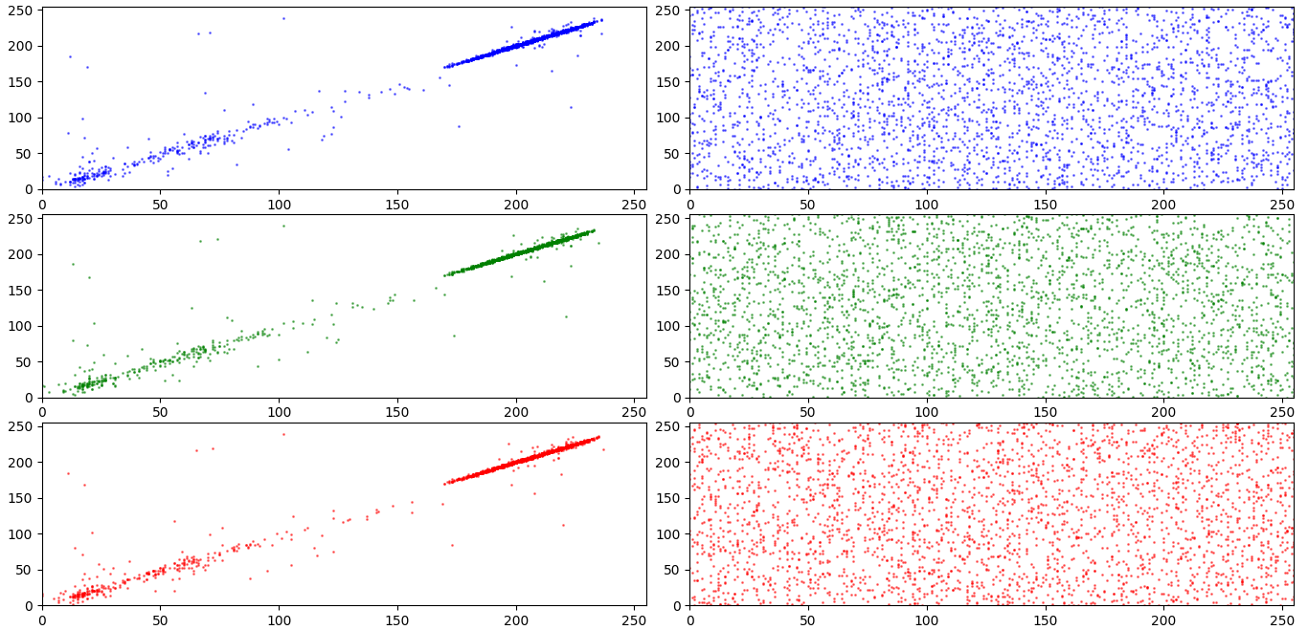

Metric | Original | Encrypted
Entropy | 7.1496 | 7.9997
PSNR | 7.5494 | -
NPCR (%) | 99.6143 | -
UACI (%) | 34.2761 | -
Correlation Horizontal (B) | 0.9115 | -0.0030
Correlation Horizontal (G) | 0.9157 | -0.0041
Correlation Horizontal (R) | 0.9157 | 0.0212
Correlation Vertical (B) | 0.9058 | 0.0249
Correlation Vertical (G) | 0.9107 | 0.0037
Correlation Vertical (R) | 0.9219 | 0.0126
Correlation Diagonal (B) | 0.8381 | -0.0120
Correlation Diagonal (G) | 0.8416 | 0.0011
Correlation Diagonal (R) | 0.8591 | -0.0017

Black




Histogram
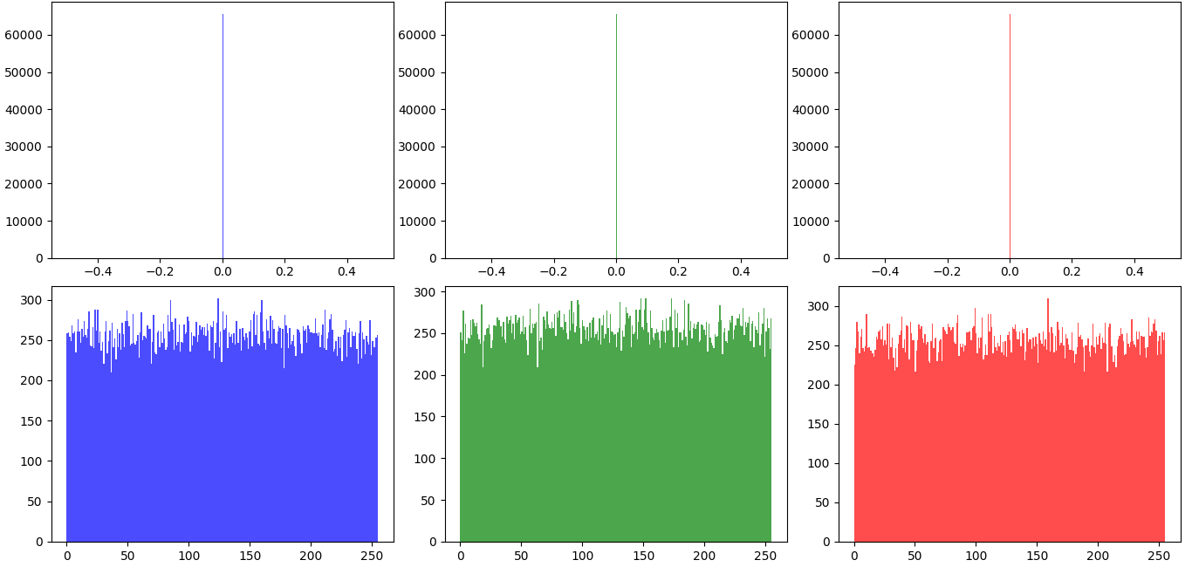

Correlation horizontal
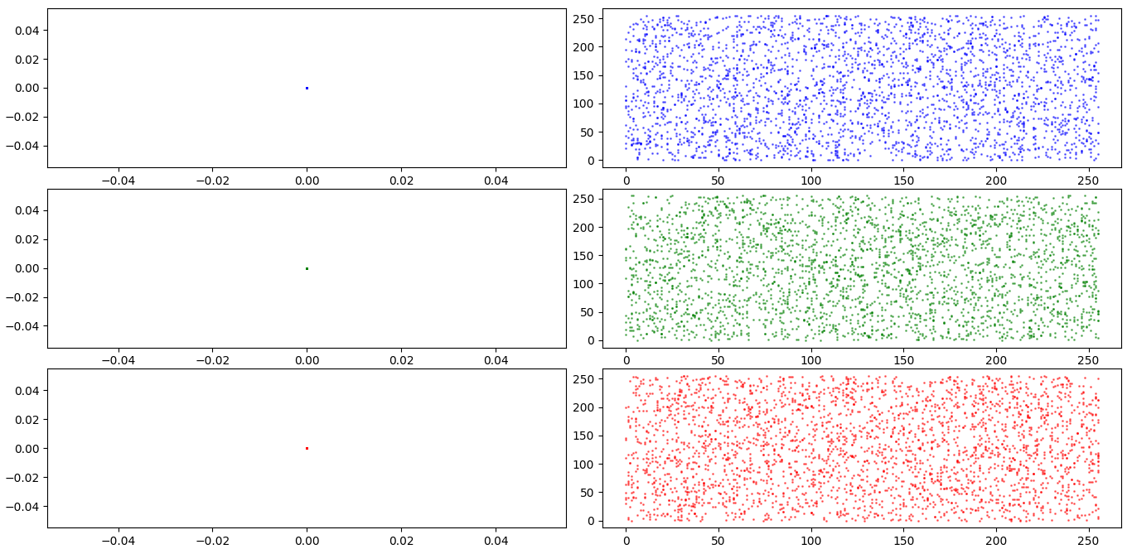

Correlation Vertical
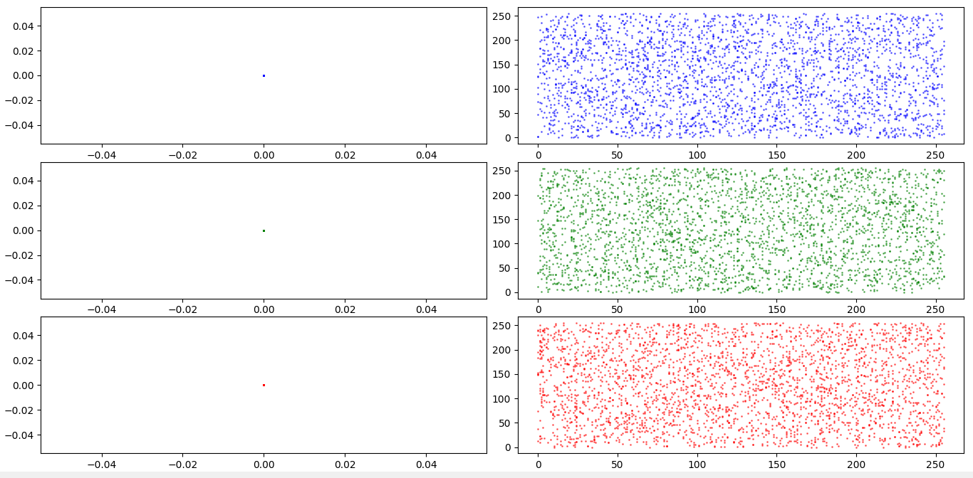

Correlation diagonal
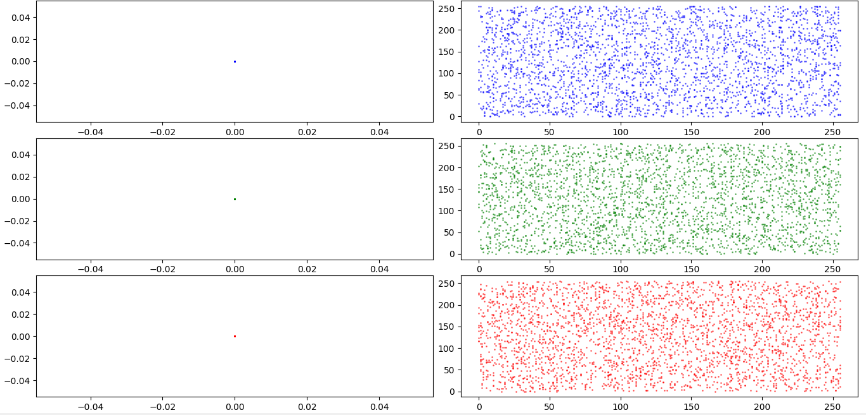

Metric | Original | Encrypted
Entropy | 0.0000 | 7.9974
PSNR | 4.7730 | -
NPCR (%) | 99.6267 | -
UACI (%) | 49.9624 | -
Correlation Horizontal (B) | nan | 0.0390
Correlation Horizontal (G) | nan | -0.0045
Correlation Horizontal (R) | nan | 0.0384
Correlation Vertical (B) | nan | -0.0098
Correlation Vertical (G) | nan | 0.0074
Correlation Vertical (R) | nan | -0.0011
Correlation Diagonal (B) | nan | 0.0245
Correlation Diagonal (G) | nan | 0.0108
Correlation Diagonal (R) | nan | 0.0162

White



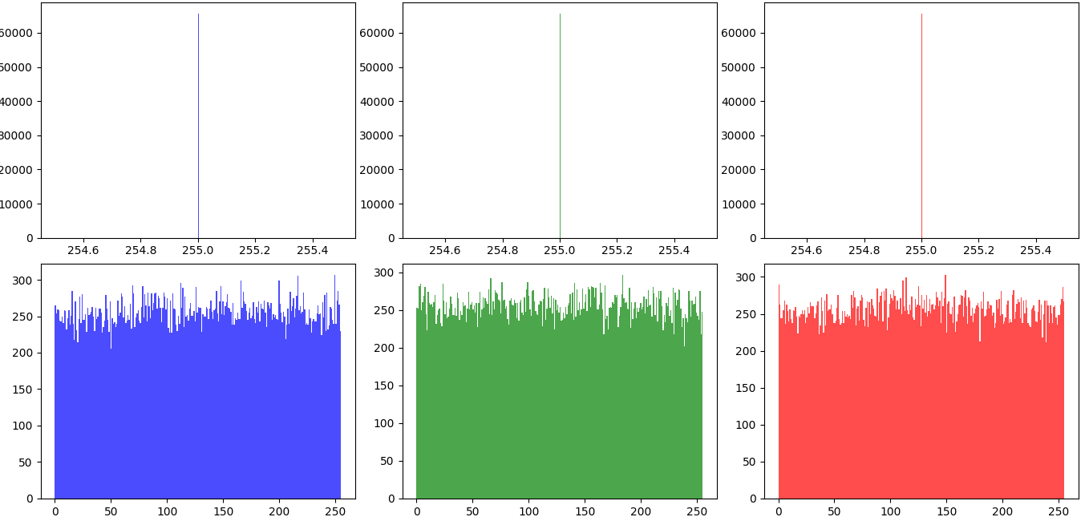
Histogram

Correlation horizontal
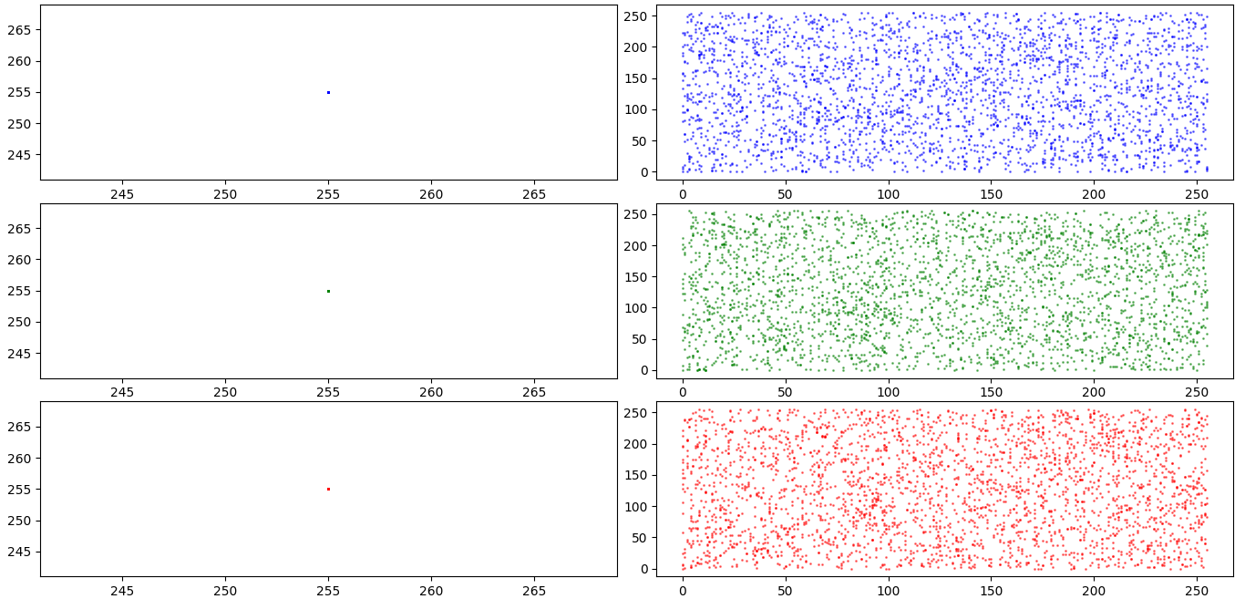

Correlation vertical
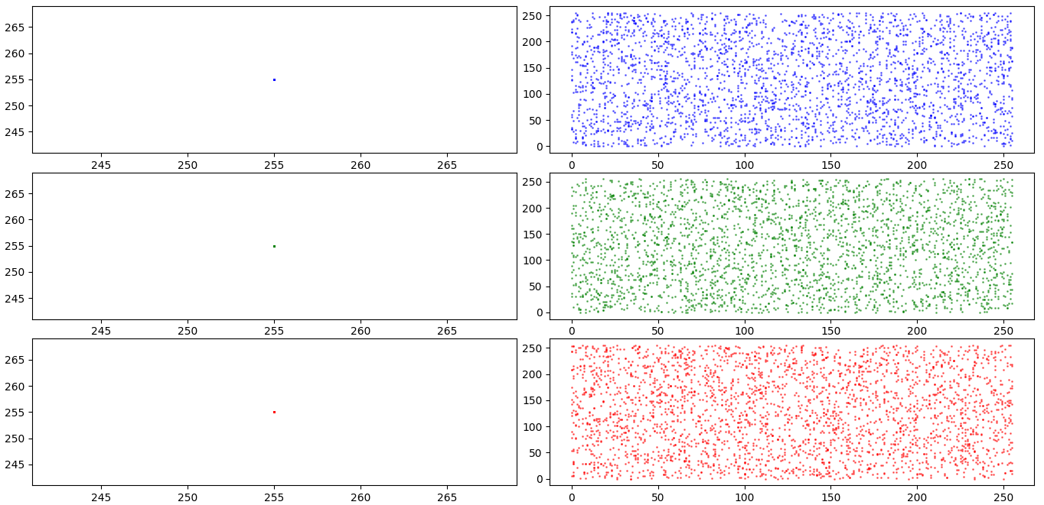

Correlation Diagonal
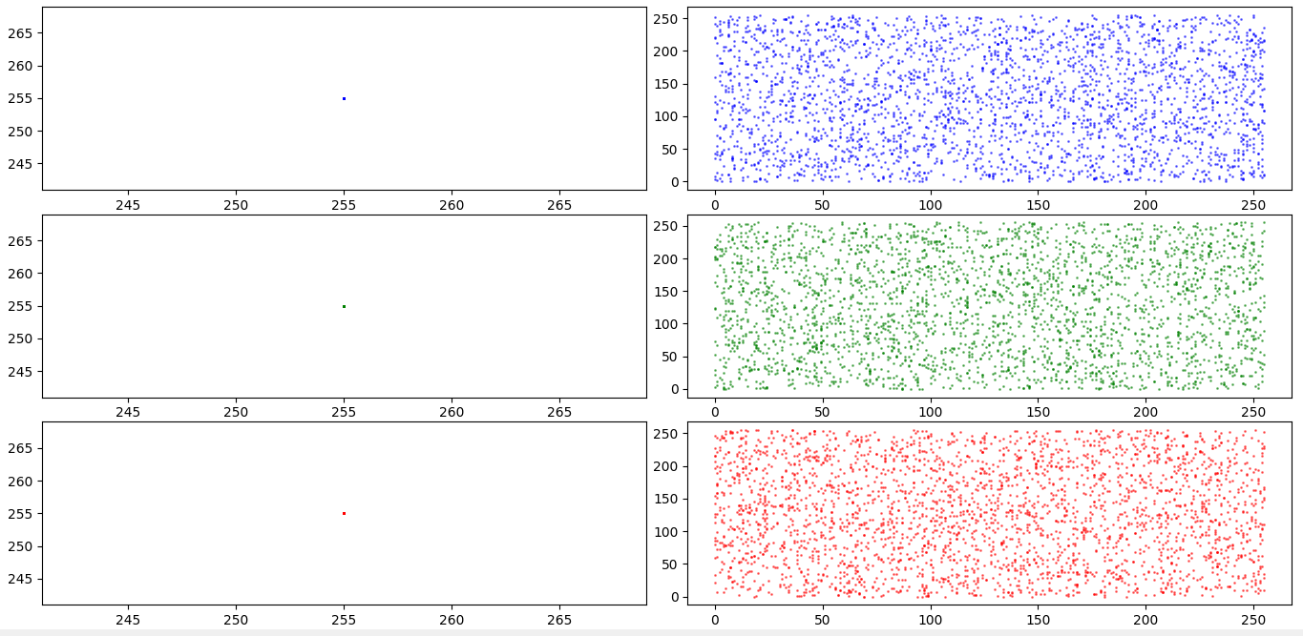

Metric | Original | Encrypted
Entropy | 0.0000 | 7.9972
PSNR | 4.7776 | -
NPCR (%) | 99.6211 | -
UACI (%) | 49.9622 | -
Correlation Horizontal (B) | nan | 0.0003
Correlation Horizontal (G) | nan | 0.0124
Correlation Horizontal (R) | nan | 0.0303
Correlation Vertical (B) | nan | 0.0045
Correlation Vertical (G) | nan | -0.0245
Correlation Vertical (R) | nan | -0.0049
Correlation Diagonal (B) | nan | -0.0347
Correlation Diagonal (G) | nan | 0.0037
Correlation Diagonal (R) | nan | -0.0133

White and Black



Histogram

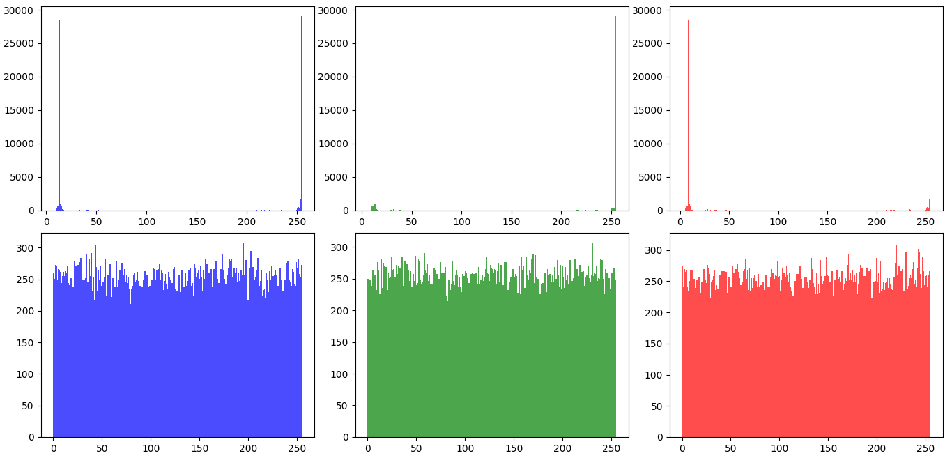

Correlation horizontal
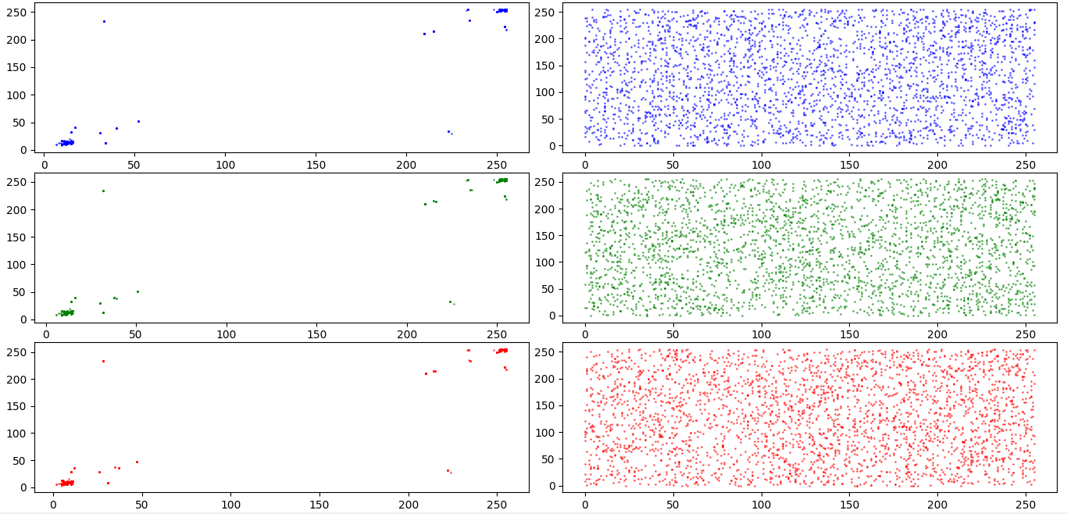

Correlation vertical
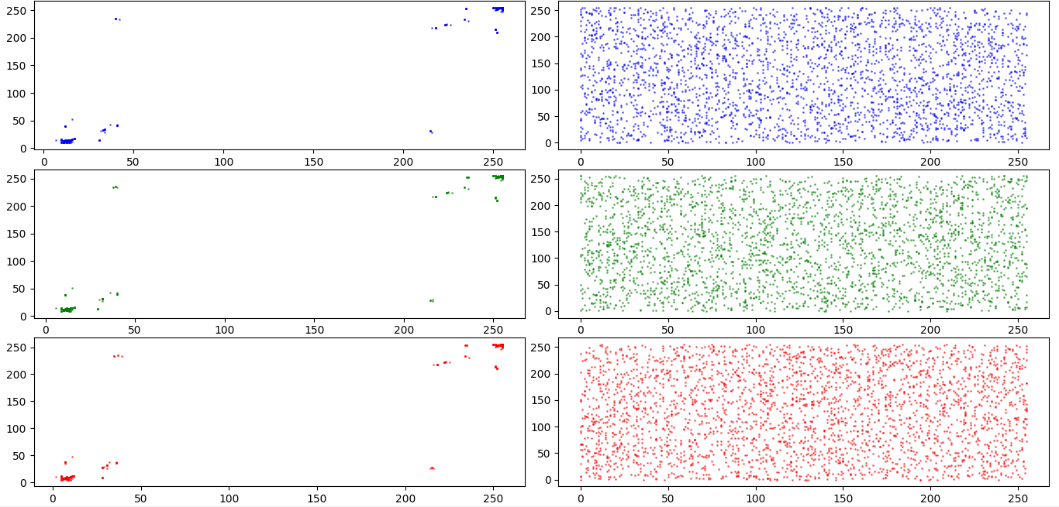

Correlation Diagonal
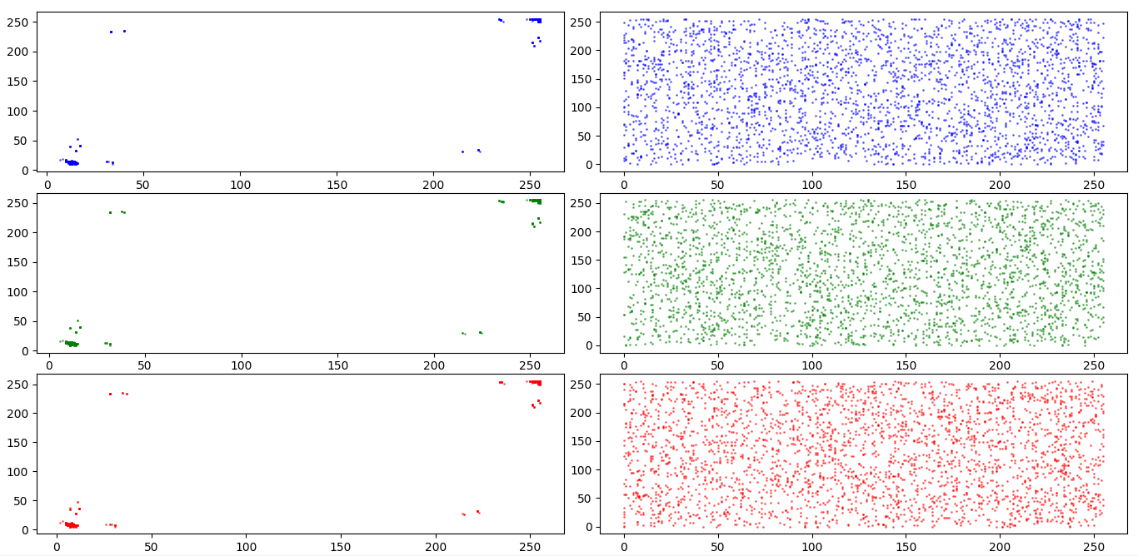

Metric | Original | Encrypted
Entropy | 1.9152 | 7.9972
PSNR | 5.0752 | -
NPCR (%) | 99.6206 | -
UACI (%) | 47.6864 | -
Correlation Horizontal (B) | 0.9951 | -0.0093
Correlation Horizontal (G) | 0.9926 | 0.0022
Correlation Horizontal (R) | 0.9918 | -0.0047
Correlation Vertical (B) | 0.9950 | -0.0327
Correlation Vertical (G) | 0.9931 | 0.0083
Correlation Vertical (R) | 0.9921 | -0.0120
Correlation Diagonal (B) | 0.9890 | -0.0137
Correlation Diagonal (G) | 0.9869 | -0.0177
Correlation Diagonal (R) | 0.9886 | -0.0111

